How to delete router ios

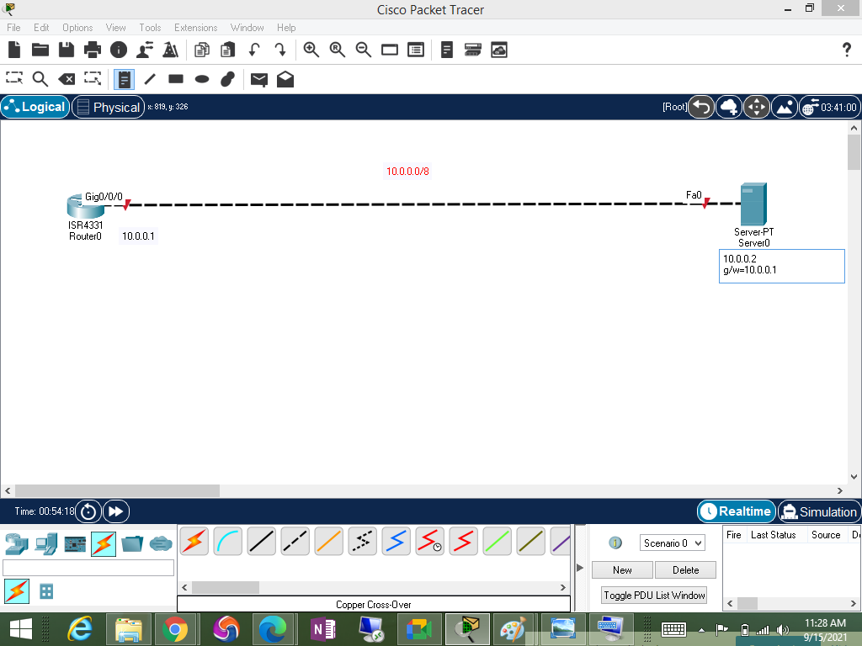

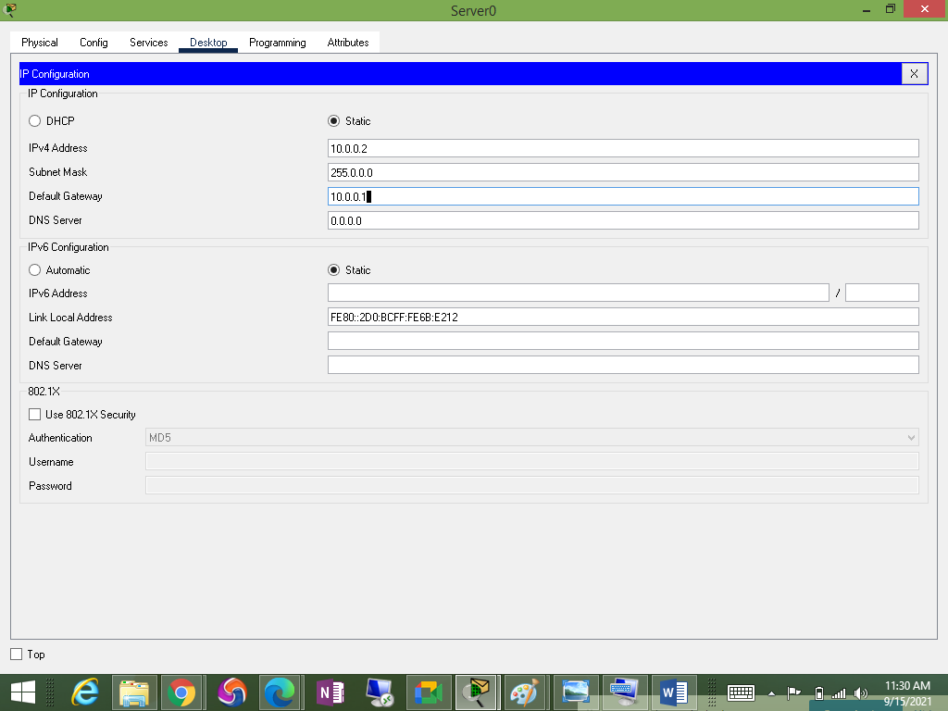

How to configure interface ip

R1#configure terminal

R1(config)#interface g0/0/0

R1(config-if)#ip address 10.0.0.1 255.0.0.0

R1(config-if)#no shutdown

How to take ios back from router to tftp server

R1#show flash

System flash directory:

File Length Name/status

3 486899872isr4300-universalk9.16.06.04.SPA.bin->copy this file

2 28282 sigdef-category.xml

1 227537 sigdef-default.xml

[487155691 bytes used, 2761893909 available, 3249049600 total]

3.17338e+06K bytes of processor board System flash (Read/Write)

R1#copy flash: tftp

Source filename []? isr4300-universalk9.16.06.04.SPA.bin->past it<eneter>

Address or name of remote host []? 10.0.0.2<enter>

Destination filename [isr4300-universalk9.16.06.04.SPA.bin]?<enter>

How to delete ios

R1#show flash

System flash directory:

File Length Name/status

3 486899872isr4300-universalk9.16.06.04.SPA.bin

2 28282 sigdef-category.xml

1 227537 sigdef-default.xml

[487155691 bytes used, 2761893909 available, 3249049600 total]

3.17338e+06K bytes of processor board System flash (Read/Write)

R1#delete flash: isr4300-universalk9.16.06.04.SPA.bin

^

% Invalid input detected at '^' marker.

R1#delete flash:isr4300-universalk9.16.06.04.SPA.bin

Delete filename [isr4300-universalk9.16.06.04.SPA.bin]?

Delete flash:/isr4300-universalk9.16.06.04.SPA.bin? [confirm]

R1#reload

How to install ios

rommon 2 > IP_ADDRESS=10.0.0.1

rommon 3 > IP_SUBNET_MASK=255.0.0.0

rommon 4 > DEFAULT_GATEWAY=10.0.0.2

rommon 5 > TFTP_SERVER=10.0.0.2

rommon 6 > TFTP_FILE=isr4300-universalk9.16.06.04.SPA.bin

rommon 7 > tftpdnld

Do you wish to continue? y/n: [n]: y

rommon 8 >boot